THE NATIONAL ASSOCIATION OF GRADUATE-PROFESSIONAL STUDENTS

Legislative Letters
February 19th, 2021
Subscribe

Updates in Higher Education

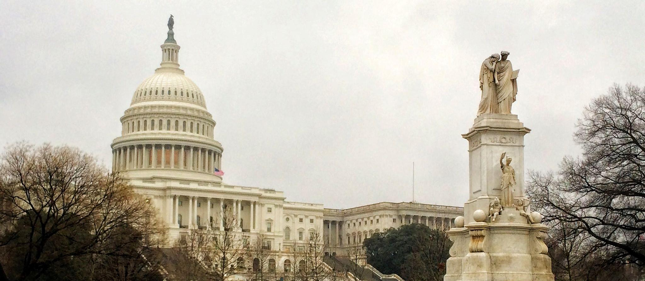
Image Credit: Kaylynne Glover, “The Capitol”

The Biden administration slowed from the breakneck pace of their first two weeks while confirmation and reconciliation processes are underway. Several notable higher education bills have been reintroduced, including the RISE Act and the Supporting Early Career Researchers Act. The Department of Education continues to fill positions in the Office of Postsecondary Education, and released a memo regarding the application of the Bostock case to title IX.

THE EXECUTIVE BRANCH

THE DEPARTMENT OF EDUCATION
More appointees have been announced for the new department of Education. As we did in our previous legislative letter, let’s take a look at who is coming in on higher education:
Michelle Asha Cooper, Deputy Assistant Secretary, Office of Postsecondary Education: former president of the Institute for Higher Education Policy, a DC-based nonprofit dedicated to expanding access to higher education. She has also previously served in the Education department, on the advisory committee on student financial assistance. She will be serving as acting Assistant Secretary, where she will be coordinating Federal Student Aid, as well as the Office of Career, Technical and Adult Education.
Joanna Darcus, Senior Counsel, Office of General Counsel: former staff attorney at the National Consumer Law Center and member of the Student Loan Borrower Assistance Project. She has spent her career working on the behalf of student borrowers, and we look forward to seeing this continue during her service.
The Education also released the first part of its guidelines for school reopening. Though this portion is aimed at primary and secondary institutions, we expect the next portion to cover topics more relevant to higher education. Two notable items expected to be covered in the next volume are “meeting the social, emotional, mental health, and academic needs of students” and “supporting educator and school staff well-being.”

WHITE HOUSE AND OTHER AGENCIES
President Biden went on the record this week concerning student loan forgiveness. During a town hall in Milwaukee, he again came out in support of $10,000 in student loan forgiveness. He noted that he did not support higher amounts, as it would benefit students who attended more expensive private colleges. This comes while other Democrats are pushing for up to $50k in loan forgiveness. Approximately one-third of student borrowers hold $10k or less in student debt, and this amount would erase approximately one-quarter of all federal student debt.

IMMIGRATION AND INTERNATIONAL STUDENT CONCERNS
The US Citizenship Act of 2021 was formally introduced to the legislature yesterday. The house version is available here, the senate version here. We discussed some of the provisions in our previous legislative letter, however there are some new details that have since come up. The bill would expand dual intent status to international students, and makes it easier for them to obtain permanent residency. Furthermore, it would repeal barriers against the states offering in-state tuition to immigrant students.
One concern with this bill that we will be monitoring: in the section which restructures employment-based visas, the current bill would abolish the per-country caps on visa recipients, similarly to the Fairness for High-Skilled Immigrant Act of 2019. This has the potential to greatly increase the wait times of international students seeking employment-based visas. However, Speaker Pelosi commented that some elements of the plan may have higher odds of passing if it were to be split into different pieces of legislation. We will be monitoring developments with the bill. Stay tuned for further action on this!

THE LEGISLATIVE BRANCH

LEGISLATION
The reconciliation process is well under way, with most house committees submitting their legislation this week. We discussed many of the provisions under President Biden’s “American Rescue Plan” in our last legislative letter, but with some slight adjustments to overall numbers. The Education and Labor mark up includes $40 billion for grants to institutions of higher ed, half of which must be spent on students and text requiring proportional spending on higher Education to the average over the past few years.
The RISE Act was reintroduced earlier this week. It would allocate an additional $25 billion to federal science agencies and direct them to provide support for research that regards or was disrupted by COVID-19. The text from the 2020 version is available here.
The employee status of graduate students, primarily those at private universities, has been a topic of hot contention for the past two decades. The National Labor Relations Board (NLRB) has reversed their position on this issue 3 times in that period, in 2000, 2004, and 2016. Currently, graduate students are able to unionize under the NLRB, however the process can be fraught with challenges from their university. The reintroduction of the PRO Act may erode some of these difficulties. Not only does it greatly expand the definition of an employee, something which may help to prevent another reversal of policy at the NLRB, but also has several provisions strengthening the establishment of unions and their ability to bargain with employers. A more detailed breakdown of some of the provisions can be found here.

HEARINGS AND OVERSIGHT
The confirmation hearing of Miguel Cardona went without significant issue last week. He was then approved by the Senate Education Committee with significant bipartisan support.

THE JUDICIAL BRANCH

THE SUPREME COURT
In June of 2020, the Supreme Court held that “an employer who fires an individual merely for being gay or transgender violates Title VII of the Civil Rights Act of 1964” in Bostock v. Clayton County. This past week, the Department of Education’s Office of Civil Rights released a memorandum on how this decision may guide future decisions regarding title IX enforcement. The memorandum specifically states that the decision does not directly affect rulings under title IX, but does draw several parallels to the examined sections in title VII. It is likely that this will have to go to the court in order to be finally decided.

THE DEPARTMENT OF JUSTICE
The Department of Justice withdrew their lawsuit against Yale which alleged admissions discrimination against white and asian students. A spokesperson for the department stated that the decision was made “in light of all available facts, circumstances, and legal developments, including the November 2020 decision… rejecting a challenge to Harvard University’s consideration of race in its admission process.” Students for Fair admissions, the group suing Harvard in that case, is currently taking their action to the supreme court, and has promised to file a similar suit against Yale “in the coming days.”

RELEVANT READS

Graduate School and Campus Climate
Vaccines for Educators - But Not All Educators

Diversity, Inclusion, and Social Justice
International Student Enrollment for 2020
Interview with the authors of Broke: The racial Consequences of Underfunding Public Universities

The State of Higher Education
Chronicle of Higher Education: Trends for 2021
Overcoming budget deficits in higher education
Higher education lost 650,000 jobs last year

Higher Education Policy
Congressional Budget Office Projects surplus for Pell Grant Program.

